***Final project {TIC}***



*Section: A*

*Group : 5*

Table of Contents

Report on Information and *Communication Technologies (TIC) and Related Technologies* 3

Introduction: 4

Body: 4

1. Definition and Importance of TIC : 5

*1.2 Key Components of TIC* 6

1.3 Important of TIC 7

2. Microsoft Tools: 9

3.1 Git: 12

3.2 GitHub: 13

4. Benefits and Applications of Git and GitHub: 14

*4.1 Efficient Collaboration*: 15

4.2 Version Control: 16

4.3 Open source contribution 17

5.Google services 18

6 Conclusion: 21

# ***Report on Information and Communication Technologies (TIC) and Related Technologies***



# Introduction:

This report aims to provide an official overview of Information and Communication Technologies TIC) and relevant technologies, with a particular focus on Microsoft tools Git and GitHub. The purpose is to explore the significance of TIC in the modern world and highlight the role played by these technologies in facilitating efficient communication, collaboration, and software development .



# Body:

# *1. Definition and Importance of TIC :*



Information and Communication Technologies (TIC) refer to the diverse set of tools, applications, and systems that enable the collection, processing, storage, and dissemination of information. TIC has become an integral part of our daily lives, revolutionizing the way we communicate, access information, and conduct business. Its importance lies in its ability to enhance productivity, foster innovation, and bridge geographical barriers.

# ***1.2 Key Components of TIC***



* Hardware: Computers, servers, routers, and other physical devices.
* Software: Applications, operating systems, and programs that enable various tasks.
* Networks**:** Infrastructure that allows the connectivity and communication between devices.
* Telecommunications**:** Communication technologies, including the internet, mobile phones, and satellite systems.
* Data Management**:** Processes for collecting, storing, and managing data efficiently.
* Cybersecurity: Measures to protect digital systems, networks, and data from unauthorized access or attacks.

# 

# *1.3 Important of TIC*

* Communication: TIC enables real-time communication and collaboration globally through email, video conferencing, and messaging platforms.
* Information Access: Provides access to vast amounts of information and resources through the internet, fostering education and research.
* Automation: TIC facilitates automation of processes, improving efficiency and reducing manual workload.
* Business Transformation**:** Drives digital transformation in various industries, enhancing productivity and competitiveness.
* E-Government and E-Services**:** Governments use TIC to deliver services to citizens more efficiently through online platforms.
* Innovation: TIC is a catalyst for innovation, fostering the development of new technologies and solutions.

# *2. Microsoft Tools:*

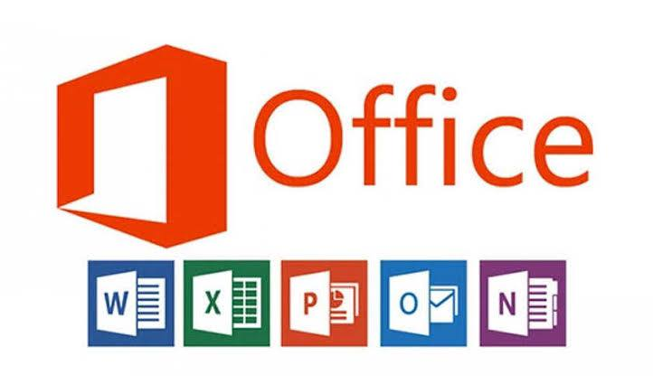

*2.1. Microsoft Word*: Beyond basic text editing, Word offers advanced formatting options, styles, templates, and collaboration features like comments and track changes. It allows users to create professional documents with tables of contents, indexes, and bibliographies. Additionally, it supports mail merge for personalized documents and offers accessibility features to enhance inclusivity.

*2.2. Microsoft Excel:* Excel is powerful for data analysis and manipulation. It includes functions for statistical, financial, and engineering calculations. Advanced users can create macros and write Visual Basic for Applications (VBA) code to automate tasks. Pivot tables and Pivot Charts enable users to summarize and visualize data efficiently. Excel also supports data connectivity with external sources and can create data models for more complex analysis.

*2.3. Microsoft PowerPoint:* Apart from creating slideshows, PowerPoint allows users to rehearse presentations, record narration, and incorporate animations and multimedia elements. It offers various design templates and themes for professional-looking presentations. Presenter view provides presenters with additional tools for delivering presentations effectively.

*2. 4. Microsoft Outlook:* Outlook integrates emails, calendars, tasks, and contacts in one interface. It supports multiple email accounts and allows users to organize their inbox with filters, rules, and categories. Outlook’s calendar feature helps schedule appointments, meetings, and events efficiently. Moreover, it provides robust security features for protecting emails and sensitive information.

*2. 5. Microsoft Access:* Access enables users to design and create databases with relational structures. It supports building user-friendly forms and reports to present data visually. Its querying capabilities help extract specific information from large datasets. Access also provides tools for developing custom applications.

*2.6. Microsoft One Note:* One Note offers a flexible canvas for organizing information. Users can create notebooks with sections and pages, where they can input text, images, audio recordings, and drawings. It supports syncing across devices and collaboration among multiple users on shared notebooks.

*2.7. Microsoft Teams:* Teams acts as a hub for teamwork, offering features like chat, video conferencing, file sharing, and project management tools. It integrates with other Microsoft apps, enabling seamless workflow within organizations. Teams also supports third-party app integrations to extend its functionalities.

These tools collectively provide a comprehensive suite for productivity, communication, data management, and collaboration across various personal and professional environments.

# *3.1 Git:*



Git is a distributed version control system developed by Linus Torvalds, primarily used for tracking changes in source code during software development. It allows multiple developers to work on a project simultaneously, maintaining a complete history of changes made. Git ensures efficient collaboration, version control, and seamless integration of code changes.

# *3.2 GitHub:*



GitHub is a web-based platform built on top of Git, providing additional functionalities and collaboration features. It serves as a central repository for code, allowing developers to store, manage, and share their projects. With an intuitive user interface, GitHub enables teams to work together, contribute to open-source projects, and track issues and bug fixes effectively

# *4. Benefits and Applications of Git and GitHub:*

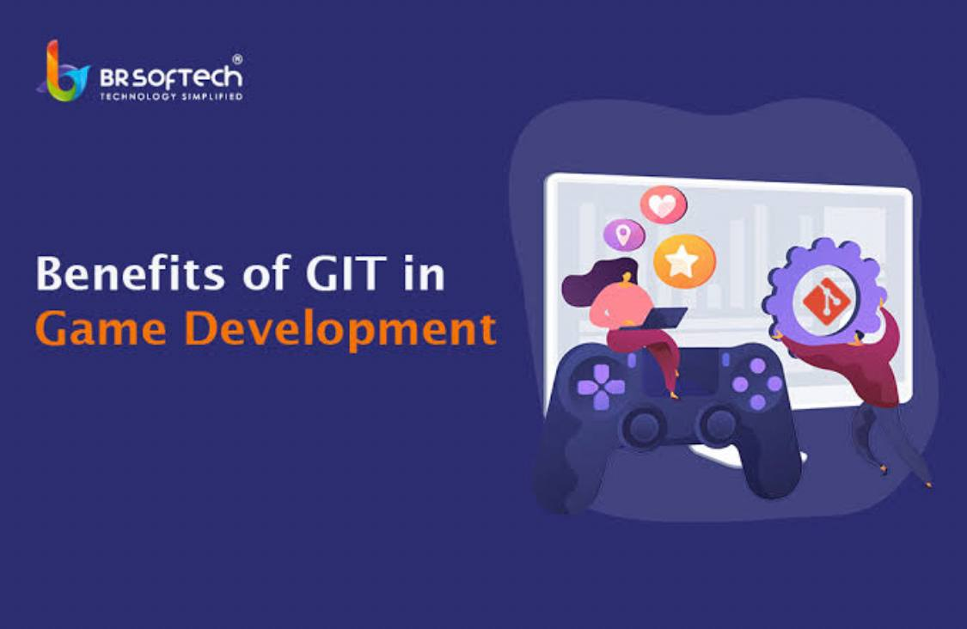

* Benefit**:** Git allows developers to create branches for different features or bug fixes. This enables parallel development without affecting the main codebase.
* Application**:** Developers create branches for new features, bug fixes, or experimental changes. Once tested and complete, branches can be merged back into the main code base.
* Benefit**:** GitHub serves as a remote repository for Git projects, providing a centralized location for code storage, backup, and collaboration.
* Application**:** Developers can push their local Git repositories to GitHub, making it accessible to others, and ensuring a secure backup of the code base.

# *4.1 Efficient Collaboration*:



Git and GitHub make it easier for developers to collaborate on projects, facilitating seamless code sharing, branching, and merging. This enhances productivity, encourages teamwork, and ensures that everyone is working on the latest version of the code base.

# *4**.2 Version Control:*

With Git' s version control capabilities, developers can track changes made to the code base over time. This allows for easy identification of bugs, reverting to previous versions, and maintaining a clean and stable code base.

# *4.3 Open source contribution*



GitHub provides a platform for developers to contribute to open-source projects, fostering community-driven innovation and knowledge sharing. It has played a significant role in the growth and success of the open-source community.

In summary, Git and GitHub offer a robust set of features and benefits for version control, collaboration, code review, and project management. These tools are widely used in software development, providing a foundation for efficient, transparent, and collaborative coding practices.

# *5.Google services*

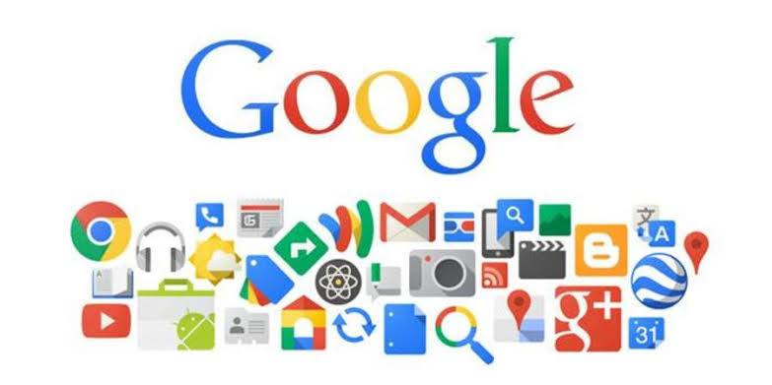*5.1. Google Search:* Besides basic keyword-based searches, Google’s search engine employs algorithms like Rank Brain and BERT for understanding natural language queries and providing more relevant results. It offers various specialized search functions such as image search, news search, and voice search.

*5.2. Gmail :*Apart from email functionality, integrates with Google Chat, allowing users to communicate through instant messaging and video calls. It also categorizes emails using tabs like Primary, Social, Promotions, and provides robust spam filtering.

*5.3. Google* Maps: Beyond navigation, Maps offers features like location sharing, real-time traffic updates, local business information, reviews, ratings, and indoor maps for certain locations like airports and malls.

*5.4. Google Drive:* It’s not just cloud storage; Google Drive integrates with Google Workspace (formerly G Suite) apps, allowing real-time collaboration on documents, spreadsheets, and presentations. It offers version history and advanced sharing settings.

*5.5 Google Photos:* This service includes features like automatic organization, facial recognition, and AI-powered suggestions for creating albums, animations, and collages. Users get free storage for high-quality photos and videos.

*5.6. YouTube:* Beyond video hosting, YouTube offers a platform for creators to monetize their content through advertising, memberships, and merchandise. It provides analytics tools and live streaming capabilities. Users can create multiple calendars, share them with others, set reminders, and receive event notifications. It integrates with Gmail, allowing events to be added automatically from emails.

*5.. 8. Google Translate:* Using machine learning, Google Translate supports over 100 languages for translation. It provides translations for text, websites, documents, and real-time conversation through the app.

5.9. Google Chrome: Apart from its speed and simplicity, Chrome offers synchronization across devices, extensive customization through extensions, and features like incognito mode for private browsing.

*10. Google Meet:* In addition to video conferencing, Google Meet includes features like live captions, screen sharing, recording meetings to Google Drive, and integration with other Google Workspace apps.

These services exemplify Google’s commitment to providing accessible, user-friendly, and innovative tools for various aspects of everyday life, ranging from productivity and communication to entertainment and information access.

# *6 Conclusion:*

Information and Communication Technologies (TIC) have become an integral part of our lives, revolutionizing the way we communicate and collaborate. Microsoft tools such as Git and GitHub have further enhanced the efficiency and effectiveness of software development processes. The seamless integration of these technologies enables developers to collaborate, track changes, and contribute to projects with ease. As TIC continues to evolve, it is essential to embrace and leverage these technologies to stay ahead in the rapidly advancing digital landscape.